Object:

Implement the following equation.

X = A’B + AB

Diagram:

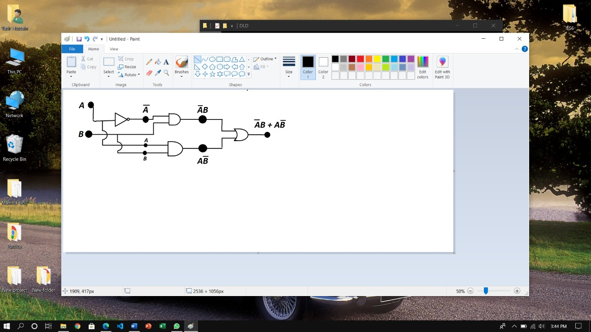

Truth Table:

|  |  |  |  |  |  |
| --- | --- | --- | --- | --- | --- |
| **A** | **B** | **A’** | **A’B** | **AB** | **A’B + AB** |
| 0 | 0 | 1 | 0 | 0 | 0 |
| 0 | 1 | 1 | 1 | 0 | 1 |
| 1 | 0 | 0 | 0 | 0 | 0 |
| 1 | 1 | 0 | 0 | 1 | 1 |